Pulp Racing Christmas Invitational Final Roster & Score Card

 | NAME | CLAIM TO FAME | 1 | 2 | 3 | 4 | 5 | 6 | 7 | 8 | 9 | 0 | 1 | 2 | 3 | 4 | 5 | 6 | 7 | 8 | 9 | 0 | F
1 | Bailey, Rick | Owner of opentracking.com, Corvette driver
2 | Bitterman, Aaron | Speedventures co-founder, Spec Miata and S2000 driver
3 | Chavis, Alan | Z06 driver, OTC Founder
4 | Chen, Terry | Spec Miata, Spec RX7, and Lotus Elise driver
5 | Coffey, John | Owner of Beta Motorsports, Winner of OTC U3 class
6 | Dearing, John | Viper League Driver, OTC T1 2nd place
7 | Dearing, Jonathan | Up and coming Star of Tomorrow
8 | Flaherty, Ryan | Founder of NASA-LA and OTC, Honda Challenge driver
9 | Garguilo, Paul | 1999 T1 Champ, World Challenge and Grand Am driver
10 | Halloway, Jim | Owner of Mother's car care products, crasher/thrasher of karts
11 | Hayashi, Doug | Owner of Pulp Racing, world famous author of Racing Stories, notorious cheating bastard. Plans on winning his own invitational event.
12 | Jeppesen, Jeff | Owner of Classy Cars Auto Detailing, Kart Driver, with killer cheater motor
13 | Lampe, Brian | Cal Club ITS Double Regional Winner, Winner of OTC U3 class
14 | Lindsey, John | Founder of NASA-LA and OTC, American Iron Driver
15 | Littrell, Jeff | Sports 2000 champ, Karter
16 | Mayes, Brett | Viper/Import racer, PMUM Understudy, flying in from AZ to win this event
17 | Mello, Wayne | Pulp Racing, 944 Turbo driver, more black flags in his career than any other driver.
18 | Messley, Erik | EMI Racing, Suspension guru, Grand Am/Daytona driver
19 | Oka, Craig | Viper, Porsche, and S2000 Driver
20 | Ota, Doug | Sports 2000 Podium Winner, M3 and M5 Driver
21 | Provost, Brian | M3 Driver, Godfather of OTC, Co-Driver OTC T1 Champ, flying in from TX to win this event
22 | Rauch, Will | Rumored to have most heavily modded S2000 in the Nation
23 | Rhoades, Jason | 1st Place OTC 2003 T3 class, holder of many Honda S2000 track records
24 | Schley, Aaron | Honda Drag Driver, runs 10.x in quarter mile
25 | Schley, Chad | Spec RSR Driver extraordinaire
26 | Sofronas, Brad | World Challenge BMW Touring Driver
27 | Sofronas, James | World Challenge BMW Touring Driver, owner of Global Motorsports Group
28 | Taylor, Heidi | San Diego Autocross Champ (Fastest female around)
29 | Taylor, Paul | San Diego Autocross Champ
30 | Trumpio, Jason | Founder of the car web cam, Mustang and Audi driver
31 | Vizcarra, Alex | Owner of Gruppe M Motorsports, NSX Driver
32 | Voss, Andy | International Playboy
33 | Wurth, John | Wurth Motorsports and Speedventures co-founder, T1 Vette driver
1st Place: $200 + $100 of OTC 2004 Entry + $150 Detail Gift Certificate + Plaque + Trophy. 2nd Place: $75 + $50 off 2004 Entry + Bucket of Mother’s Polishes and Waxes + Plaque + Trophy
3rd Place: $50 + Bucket of Mother’s Polishes and Waxes + Trophy Hard Charger Award: Driver in final race making up most spots (but not on podium): Bucket of Mother’s Polishes and Waxes

Prizes  Donated by: |  | 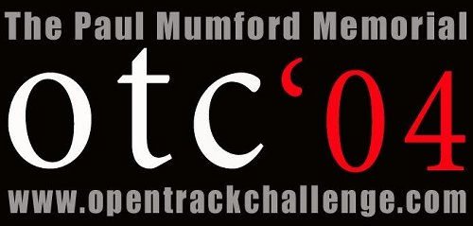 |  |  | 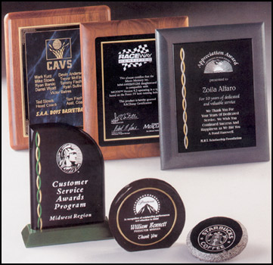
 | www.pulpracing.com | www.opentrackchallenge.com | www.classycars.com | www.mothers.com | www.awardguy.com

